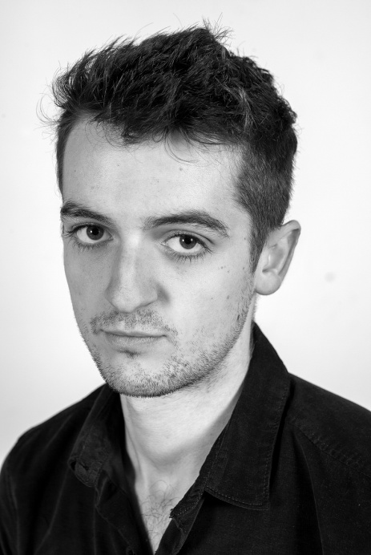

Padraic Riddle

[padraicriddle@gmail.com](mailto:padraicriddle@gmail.com)

07746227355

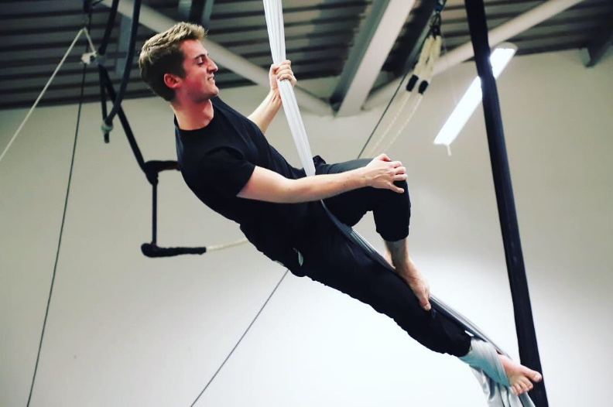

Specialist Skills

|  |
| --- |
| ACCENTS : Scottish, RP, General American |
| MUSIC/DANCE: Classical (Bass/Tenor), Scottish Country Dance. |
|  |
| OTHER: Aerial/Silks/Trapeze. |

Training

|  |  |  |
| --- | --- | --- |
| YEAR | INSTITUTION | COURSE |
| 2019  2018  2017  2016  2015-16 | PASS – Edinburgh College  PASS – Edinburgh College  PASS – Edinburgh College  PASS – Edinburgh College  Royal Conservatoire of Scotland | BA (Hons) Dance and Drama  HND Acting and Performance  HNC Acting and Performance  NC Acting and Performance  Junior Conservatoire |

Theatre

|  |  |  |  |
| --- | --- | --- | --- |
| YEAR  2020 | PERFORMANCE  Dying and Dancing | ROLE  Performer | DIRECTOR  **Festival Theatre** - Christine Devaney |
| 2019  2019  2018  2018  2017  2016 | Fissure  A Christmas Carol  The Radicalisation of Bradley Manning  Performing Portraiture (devised)  The Choosing  Romeo and Juliet | Human I  Fred  Tyler  Company  Magnus  Romeo | **Traverse Theatre** - Mary McCluskey  **PASS Theatre -** Scott Johnston  **PASS Theatre**– Ashling Findlay-Carol  **National Portrait Gallery** – Ashling Findlay-Carol  **The Citizens Theatre** – Andrew McGregor  **The Chandler Theatre** – Daniel Cameron |

Specialist Workshops

|  |  |  |
| --- | --- | --- |
| YEAR  2020 | PRACTITIONER / ARTIST  LARDS | MASTERCLASS  Physical Storytelling |
| 2020 | The Collective | Ensemble Practice |
| 2020 | Stephanie Arsoska | Ensemble Practice |
| 2019 | Euan Downie | Physical Theatre |
| 2019 | Ros Steen | Nadine George |
| 2018  2018  2018  2017  2017 | Ed Robson  Nick Bone  Jemima Levick  Helen Quinn  Peter Machen | States of Tension  View Points  Verbatim Theatre  Uta Hagen  Laben Efforts |

**Height**: 6ft **Playing Age**: 19-25 **Build**: Athletic

Padraic is a Scottish Performer and current Artist in Residence at Performing Arts Studio Scotland. Recently, Padraic has achieved a BA (Hons) Dance and Drama degree with first class from Kingston University and gained practical experience as a facilitator for Strangetown, and on professional placement with Surge theatre company Glasgow.